Verification of Boolean and De Morgan Laws

Experiment no. 4 Date:
Aim:
• To verify the basic rules of Boolean algebra using logic gates.
• To verify the two elements of De Morgan’s Theorem.
Components Required:
- 7408 IC –AND gate
- 7432 IC –OR gate
- 7404 IC – NOT gate
Theory:
Boolean algebra is similar to other mathematical topics in that there are identities that can be used to simplify the work that needs to be done. The basic identities of Boolean algebra are:
A + 0 = A A + 1 = 1
A + A = A A + A’ = 1
A*0 = 0
A*1 = A AA = A AA’ = 0
A’’ = A
A + AB = A
A + A’B = A + B
Since seeing is believing, this experiment will demonstrate all of the single variable Boolean identities using AND, OR and NOT gates in this experiment.

Recall that the DeMorgan’s Theorem (Figure 1) simplifies the inverted product (AB)’ or inverted sum (C + D)’ into a form that is more usable form for overall simplification of a digital circuit. This theorem also provides a means of converting to universal gate NAND and NOR. Both parts of DeMorgan’s Theorem will be proven in this experiment.
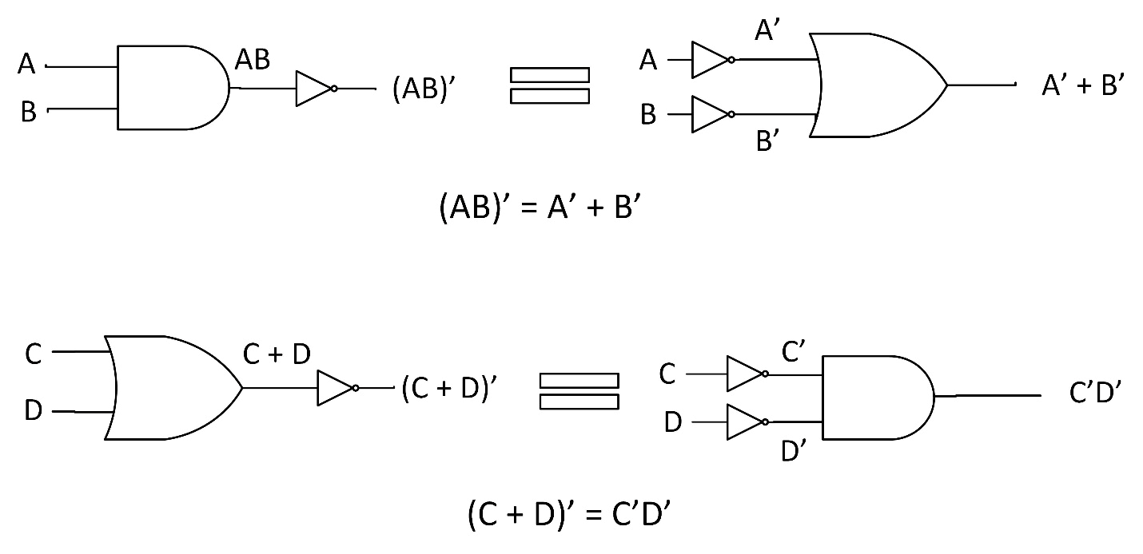

Figure 1
Procedure:

1. Verification of Boolean Identities
- Design and draw the logic diagrams for the equivalent Boolean Identity circuits in Table 1 using the AND, OR and NOT gates.
- Include the pin numbers on the gate inputs and outputs. Refer the datasheets to determine the pinout of the chips.
- Build each circuit using the trainer. Test each circuits output for both input states. Use the level switches to toggle the inputs.
- Before turning on the power to the trainer, review the wiring for errors.
- Turn on the power to the trainer.
- Record the results in Table 1.
Boolean  Identity | Experimental  Result (A, 1, 0)
A + 0 = A
A + 1 = 1
A + A = A
A + A’ = 1
A*0 = 0
A*1 = A
AA = A
AA’ = 0
A’’ = A
Table 1

Draw the equivalent Boolean identity circuit:

Procedure:

2. Verification of De Morgan’s Theorem (AB)’ = A’ + B’
Design and draw the first element of DeMorgan’s Theorem (AB)’ = A’ + B’ using the AND, OR and NOT gates. Include the pin numbers on the gate inputs and outputs. Refer the datasheets to determine the pinout of the chips.
- (AB)’

- A’ + B’

- Use AND, OR and NOT gates along with the trainer to build the two logic circuits from the first De Morgan’s Theorem (AB)’ = A’ + B’.
- Use the Level Switches to toggle the inputs.
- Before turning on the power to the trainer review the wiring for errors.
- Start with all the input switches as LOW. Turn on the power to the trainer.
- Adjust the switches to test all the input combinations and record the results in Table 2.

Inputs |  | Outputs
A | B | (AB)’ | A’ + B’

Table 2

3. Verification of De Morgan’s Theorem (C + D)’ = C’D’
Design and draw the second element of De Morgan’s Theorem (C + D)’ = C’D’ using the AND, OR and NOT gates. Include the pin numbers on the gate inputs and outputs. Refer the datasheets to determine the pinout of the chips.
(C + D)’

C’D’

- Use AND, OR and NOT gates along with the trainer to build the two logic circuits from the second De Morgan’s Theorem (C + D)’ = C’D’. Use the Level Switches to toggle the inputs.
- Before turning on the power to the trainer review the wiring for errors.
- Start with all the input switches as LOW. Turn on the power to the trainer.
- Adjust the switches to test all the input combinations and record the results in Table 3.
Inputs |  | Outputs
C | D | (C + D)’ | C’D’

Table 3

Questions:
- Simplify the Boolean equation M = W’XY’ + WXY’ + XY’Z using Boolean identities and theorems to show that M = XY’.
- Draw the logic diagrams for X = AB(A’ + BC)’ and Y = ABC’.
- Using Boolean identities and the De Morgan’s Theorem prove that X = Y for question 2.

Result :

Thus the basic Boolean laws and De Morgan’s theorem are verified.

